AKUANA order form
Order： ________________ Dealer： _______________
Contact： _______________ Phone： _______________
Email： _______________ Date：_________年/_____月/ _____日
Note： ______________________________________

Fill the Number____

Step 1: Choose Package

A. OW package. Number____

1) F3/FN2 2) F4/FN2

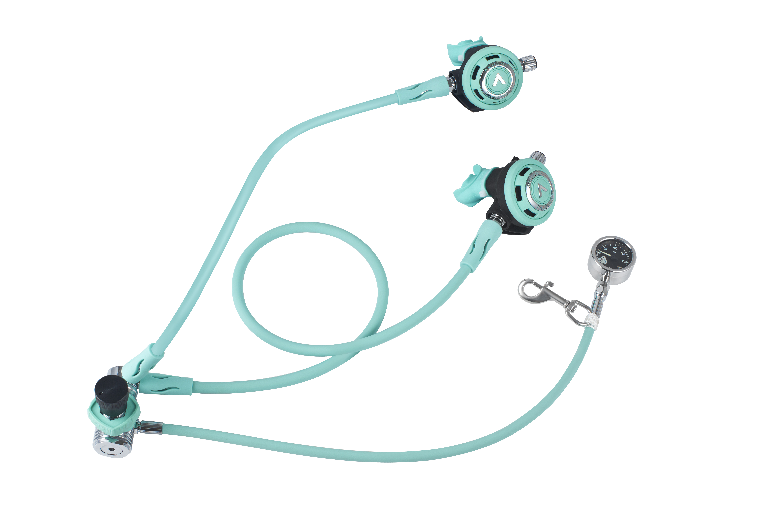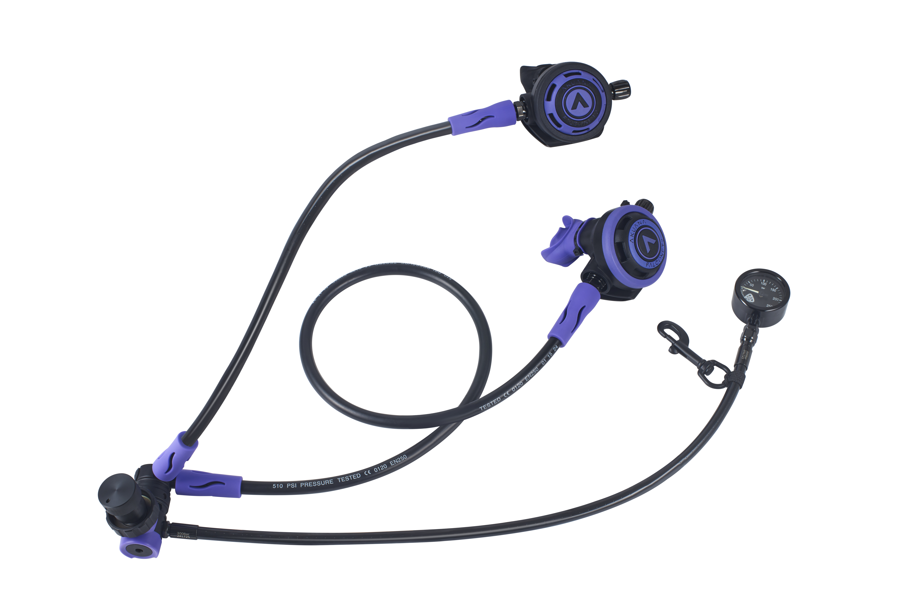

3) F4/FN2/FN3 4） F4/FN3

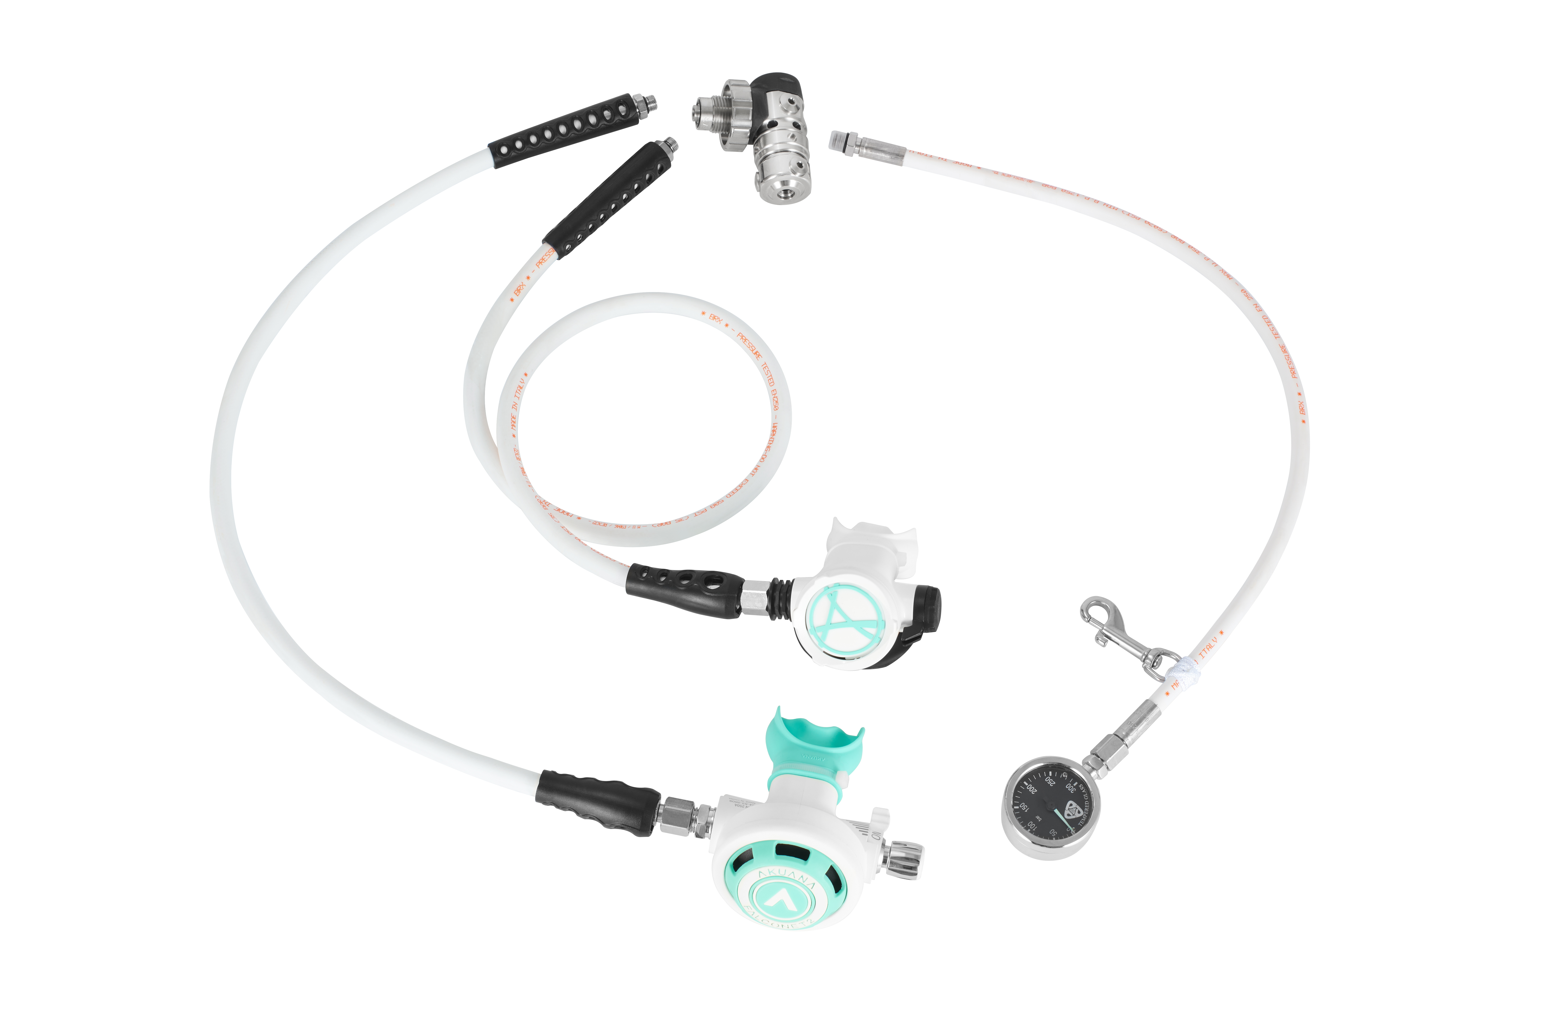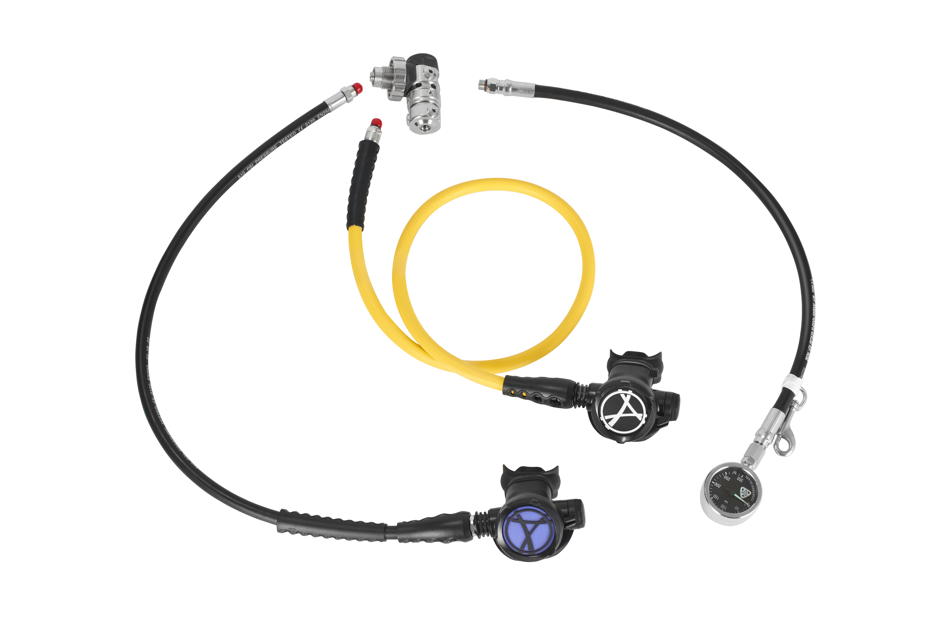

B. Horga Package. Number____
1) F3/FN2 2) F3/FN2 Gunmetal package（gunmetal hoses）

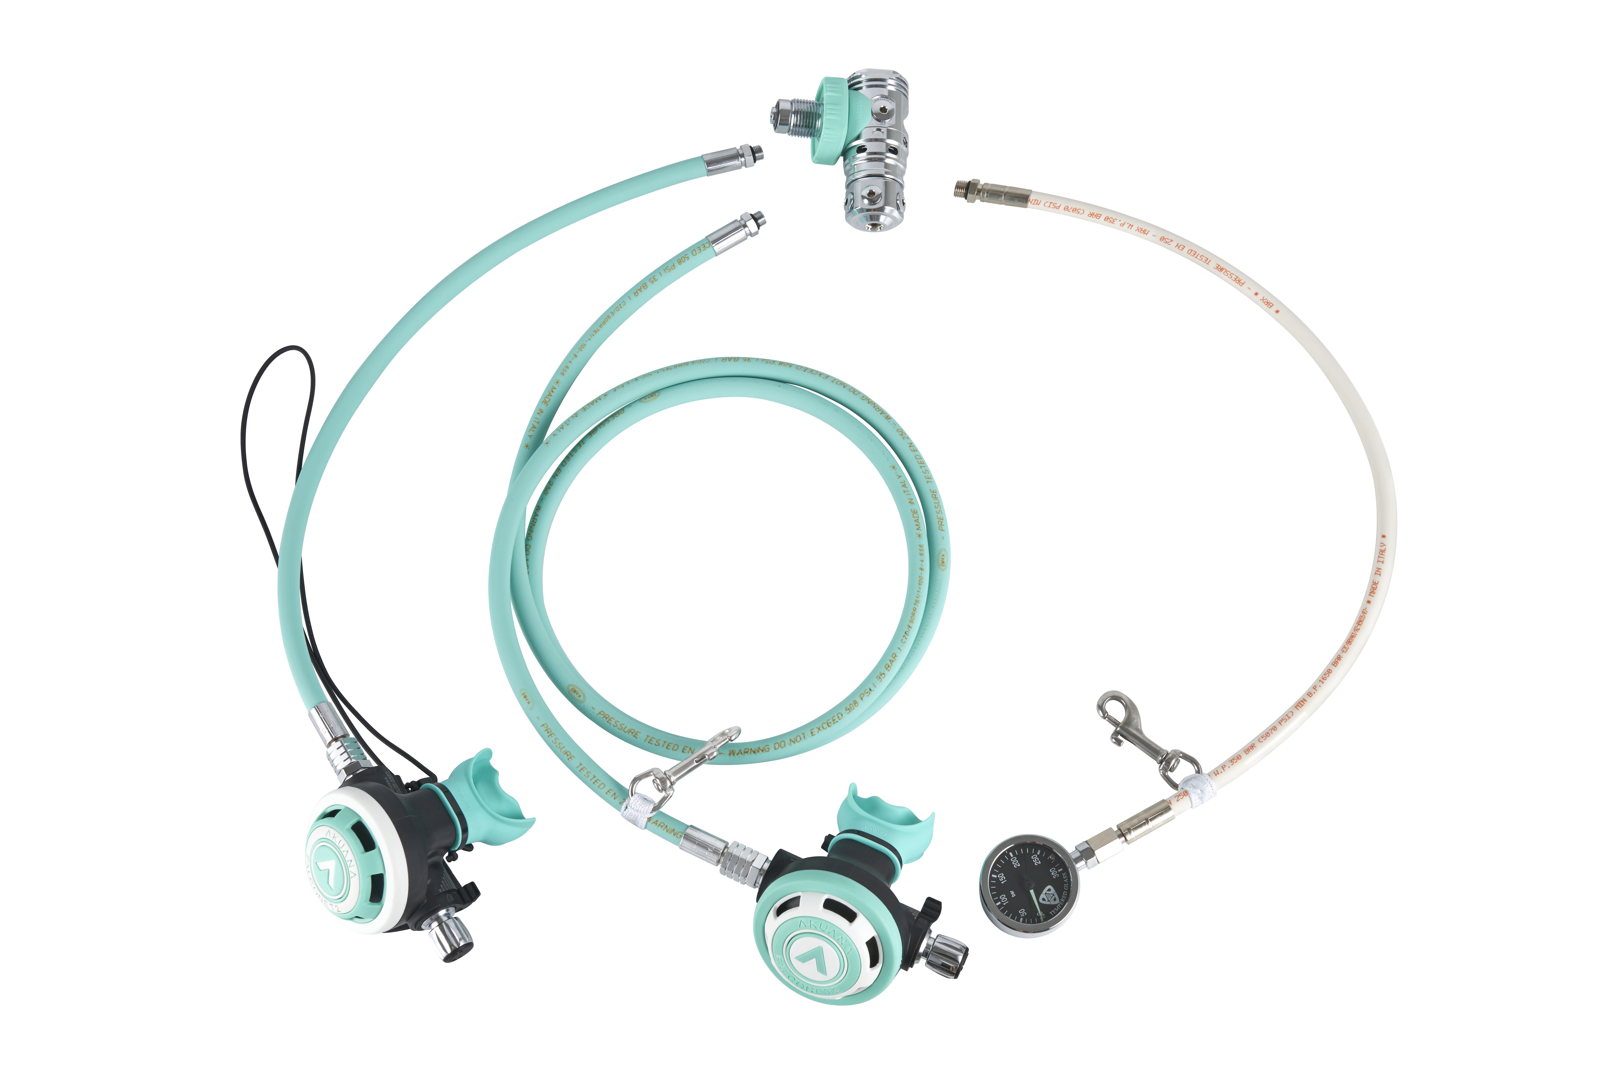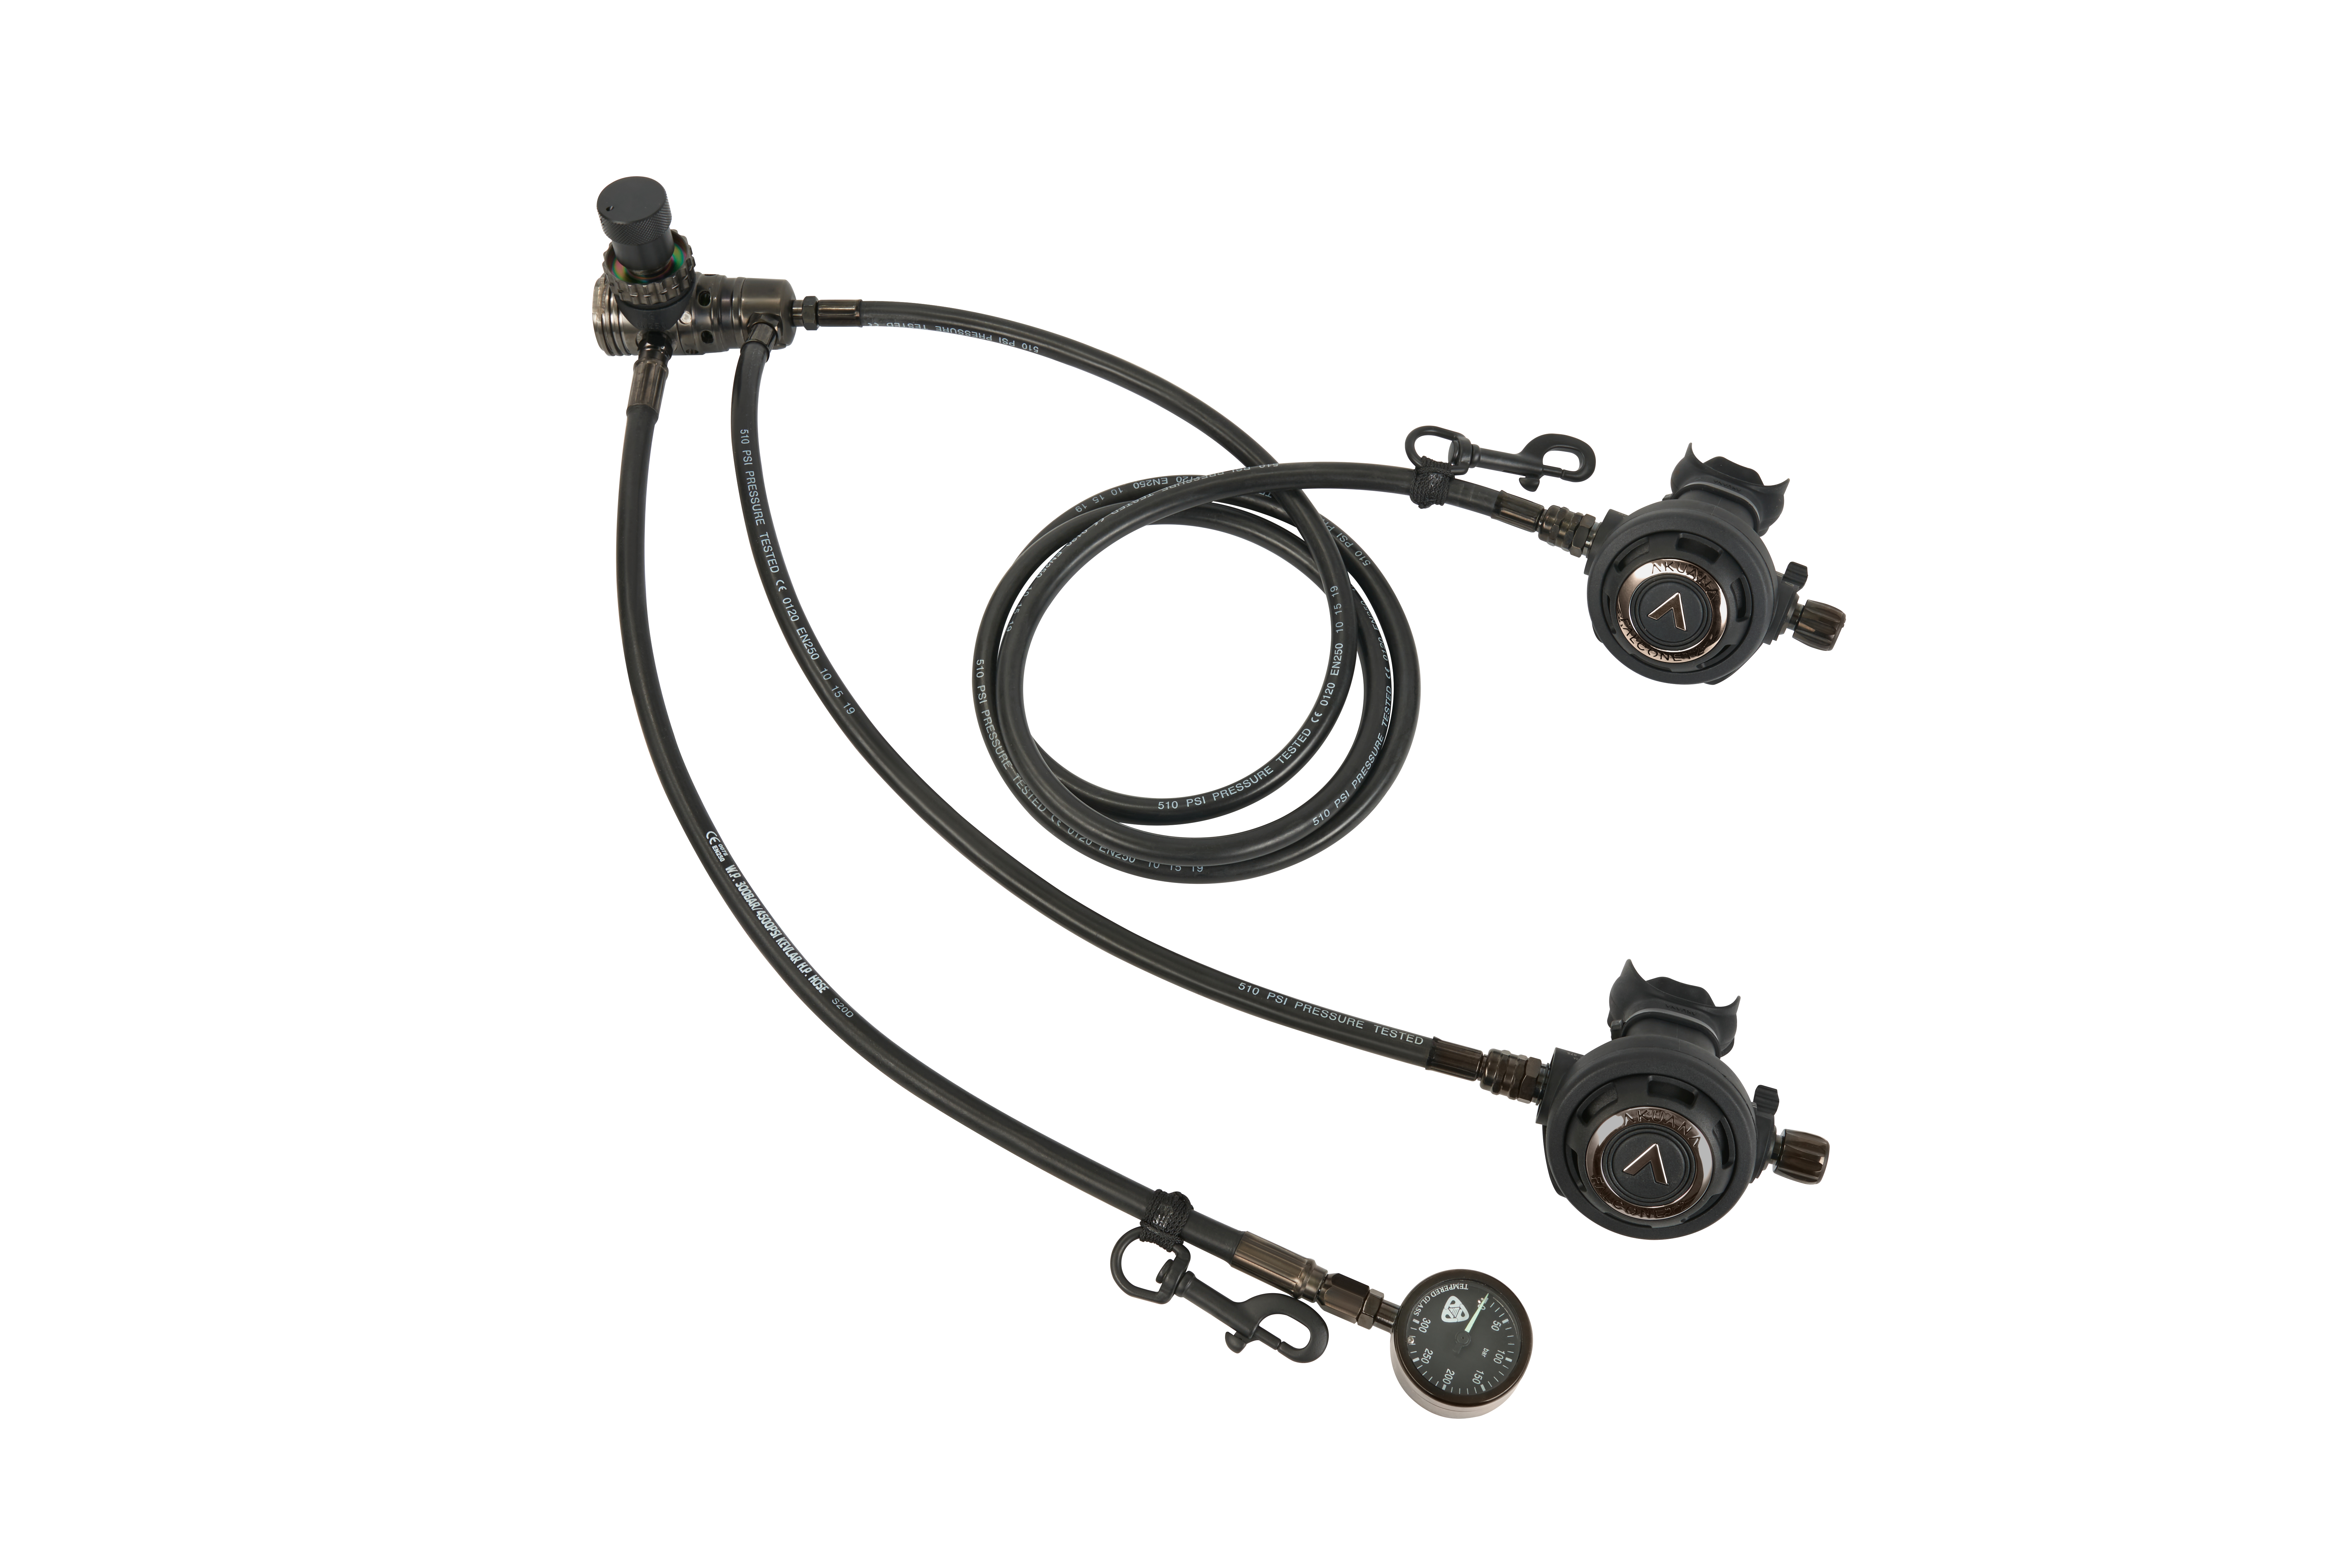

3) F5/FN2 4) F4/FN3

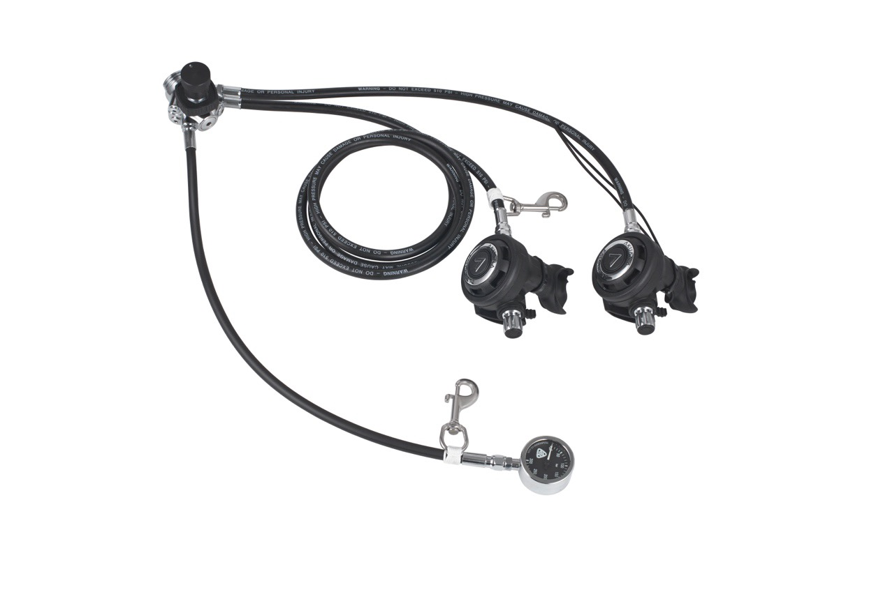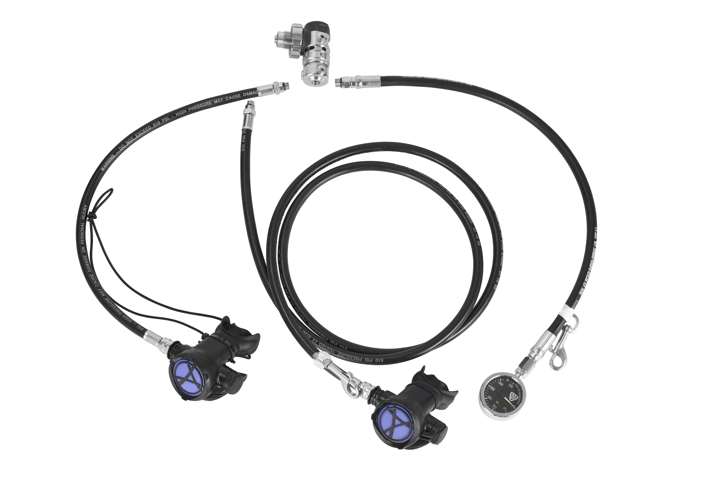

5) F4/FN2 6) F4/FN2 Gunmetal package（gunmetal hoses）

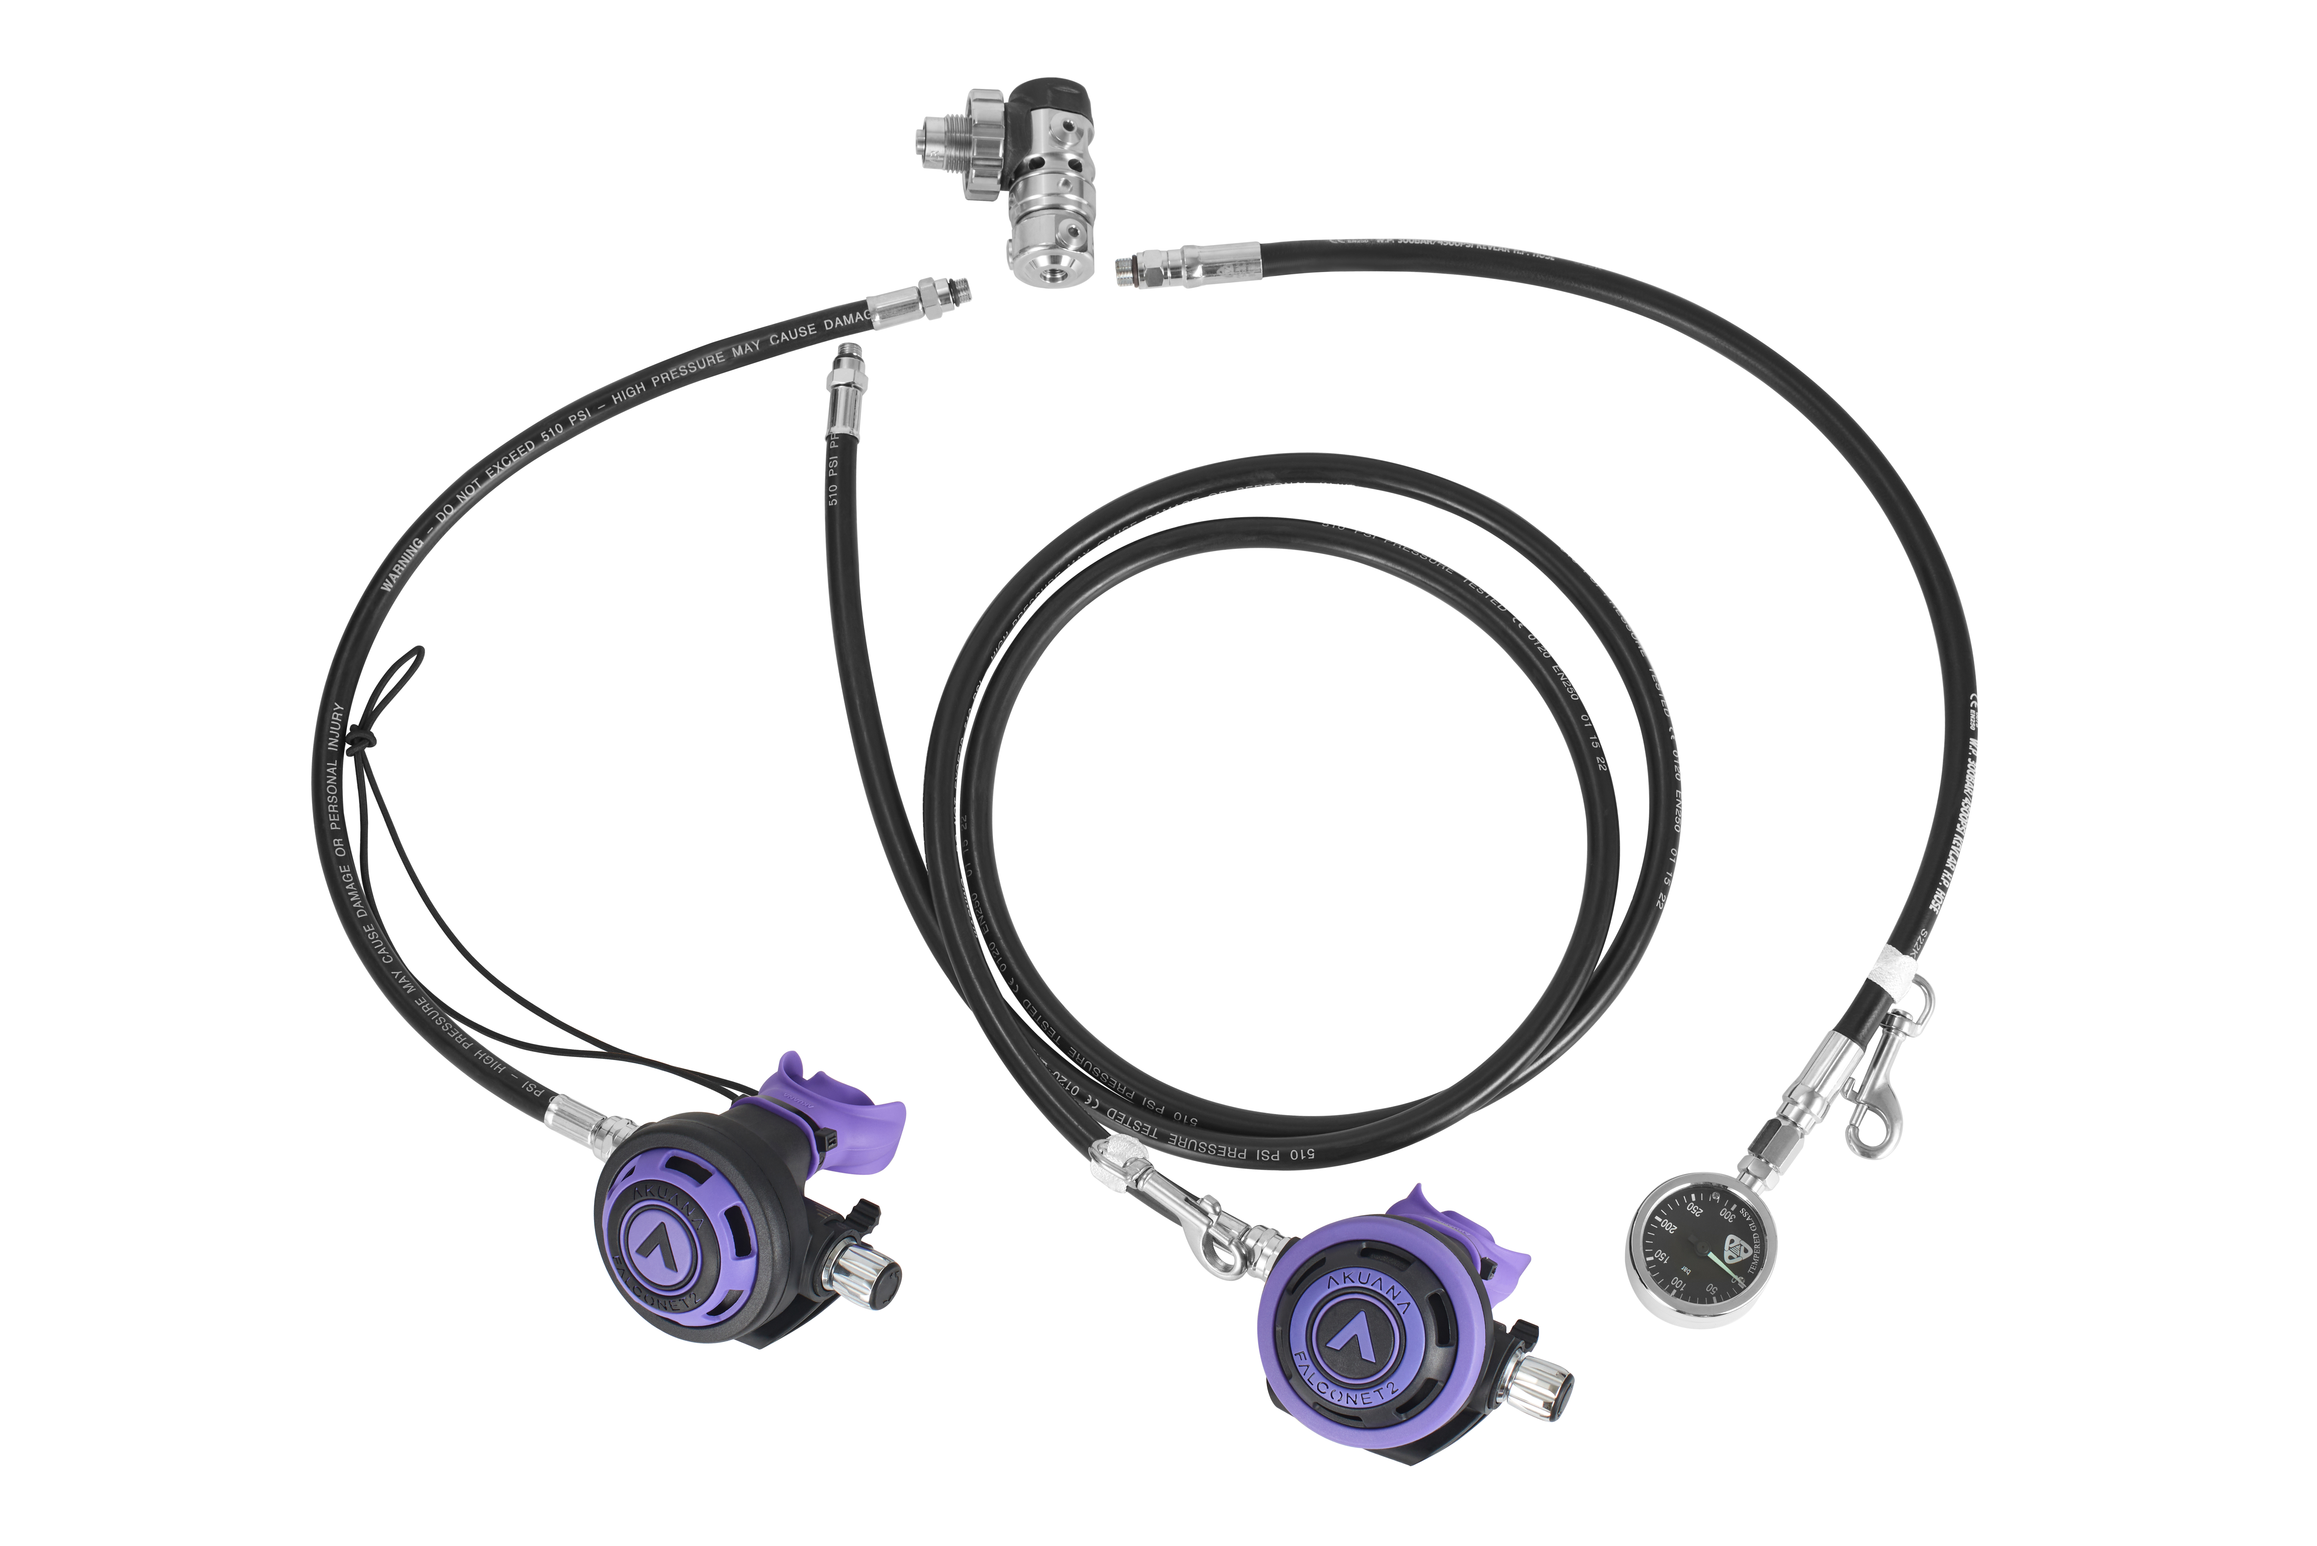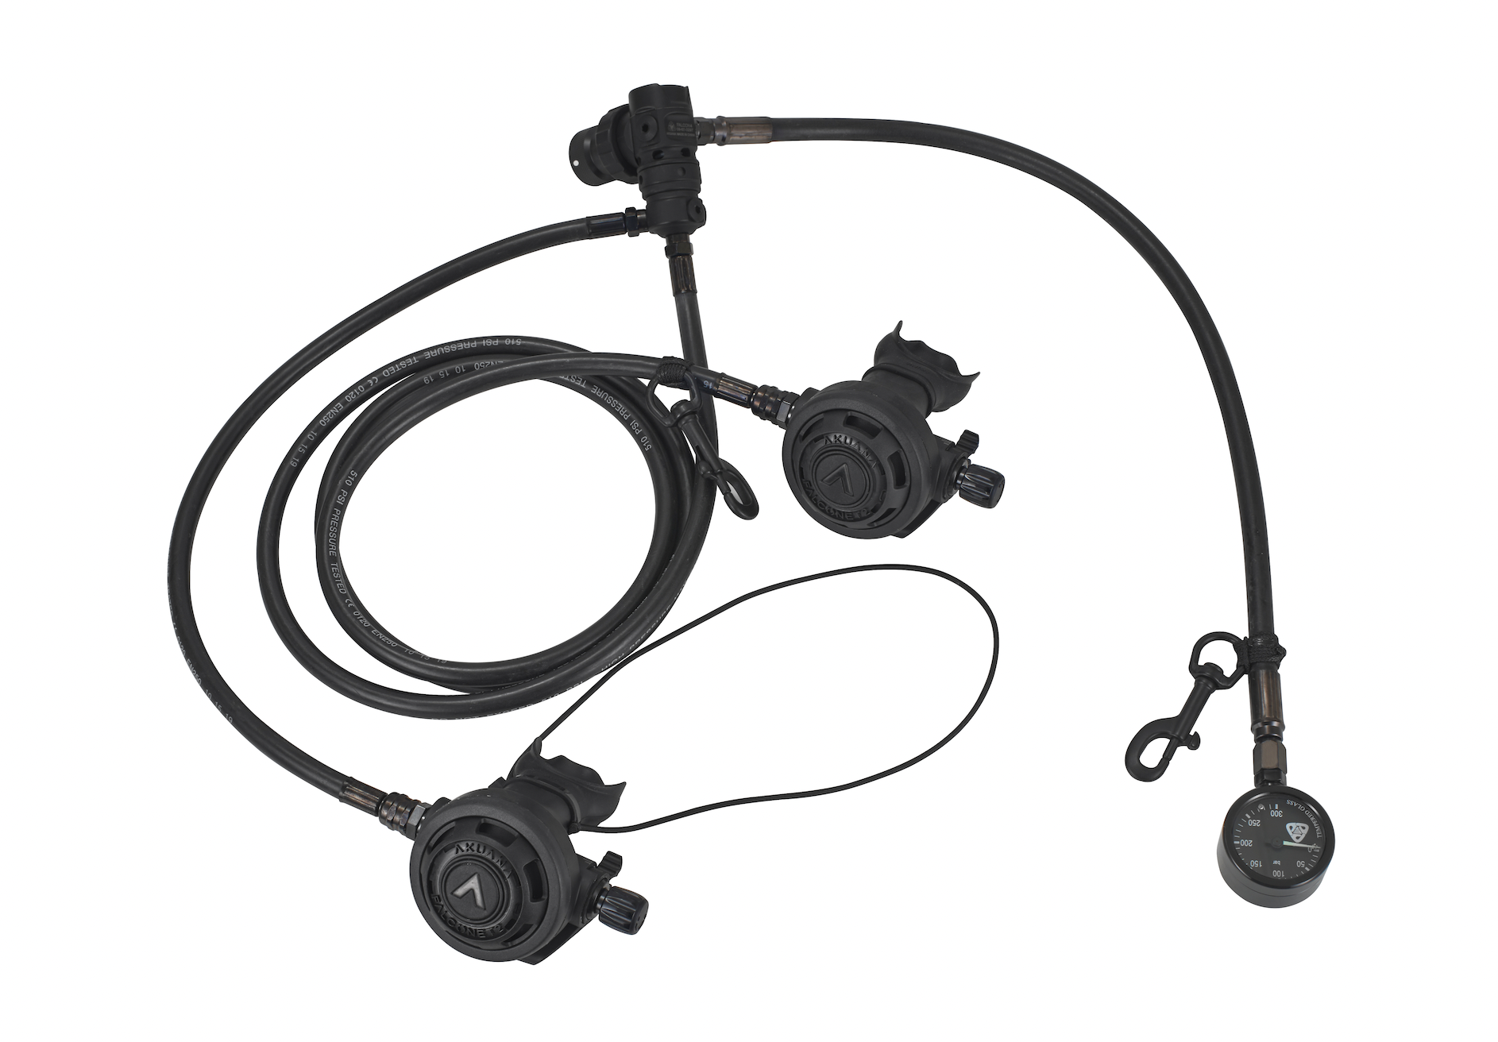

C.Double tank package. Number____
1)F3/FN2 2) F4/FN2
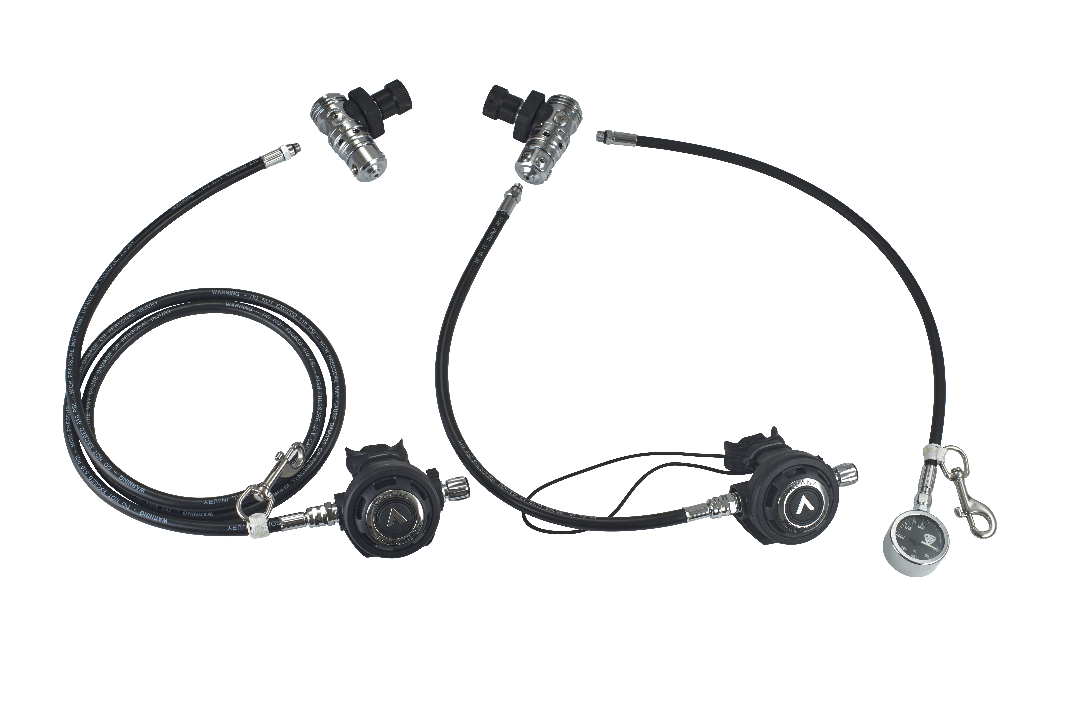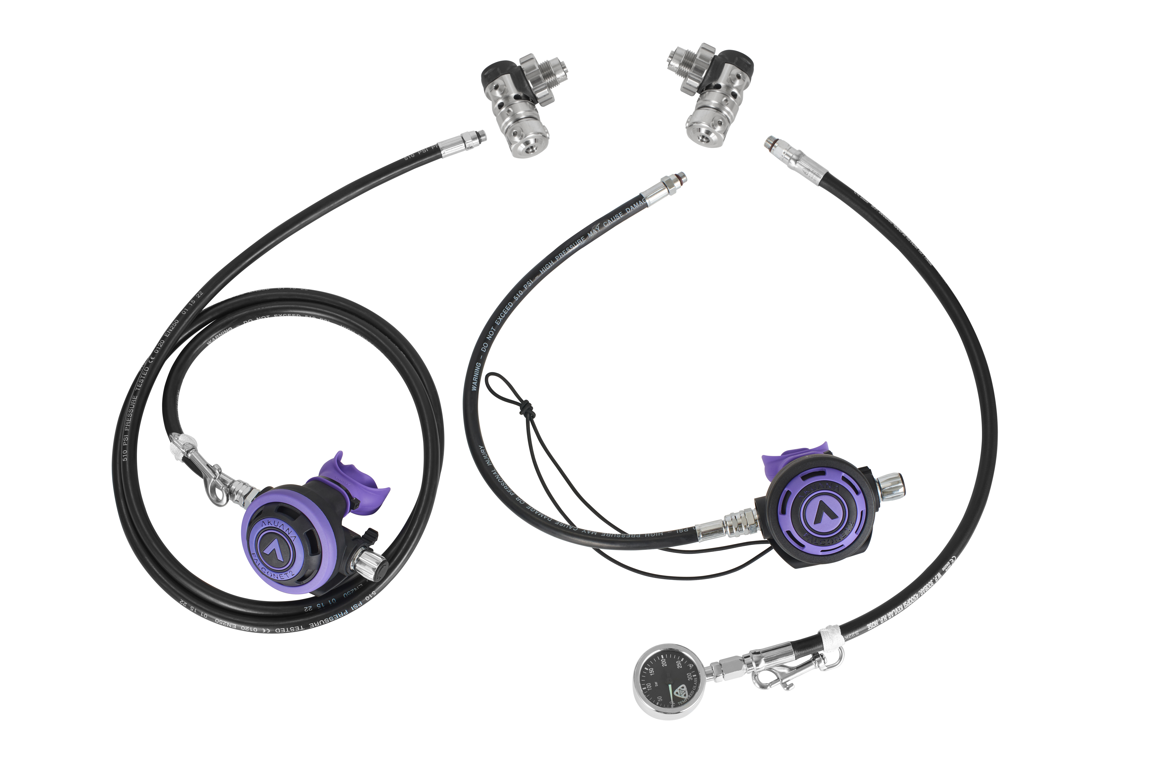

3) F5/FN2 4) F3/FN2 Gunmetal package（gunmetal hoses） 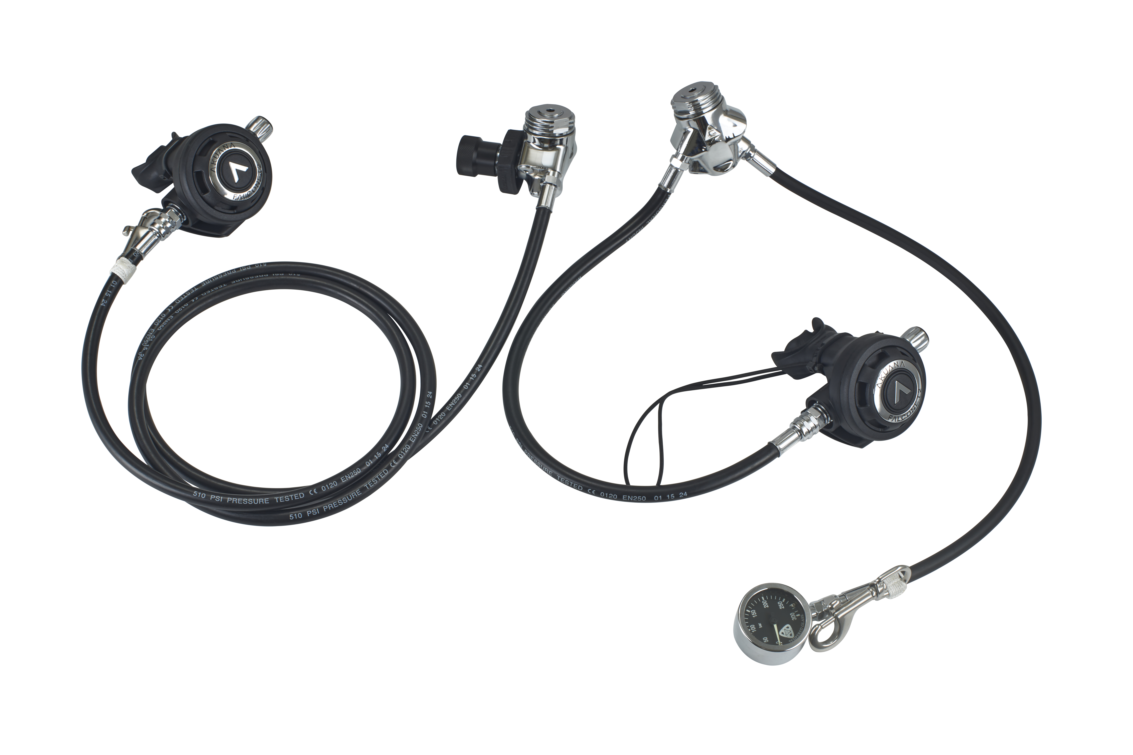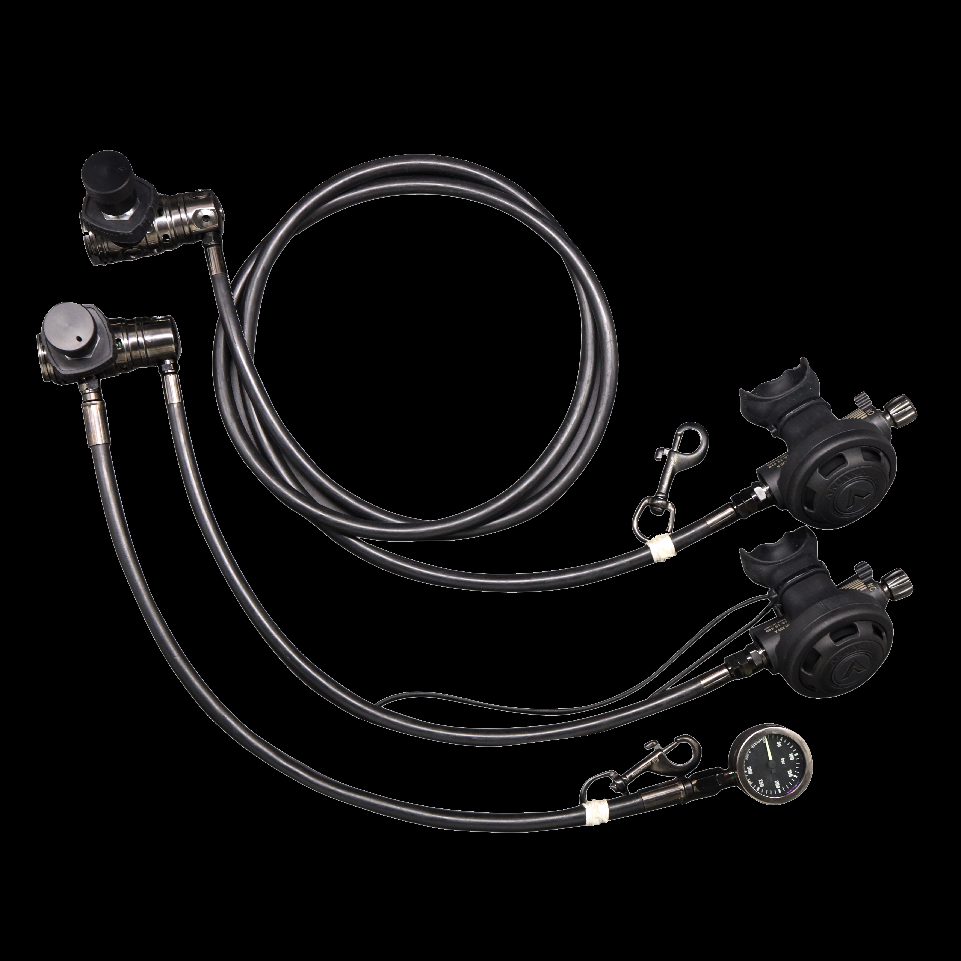

5) F4/FN2 二级头 Gunmetal package（gunmetal hoses）

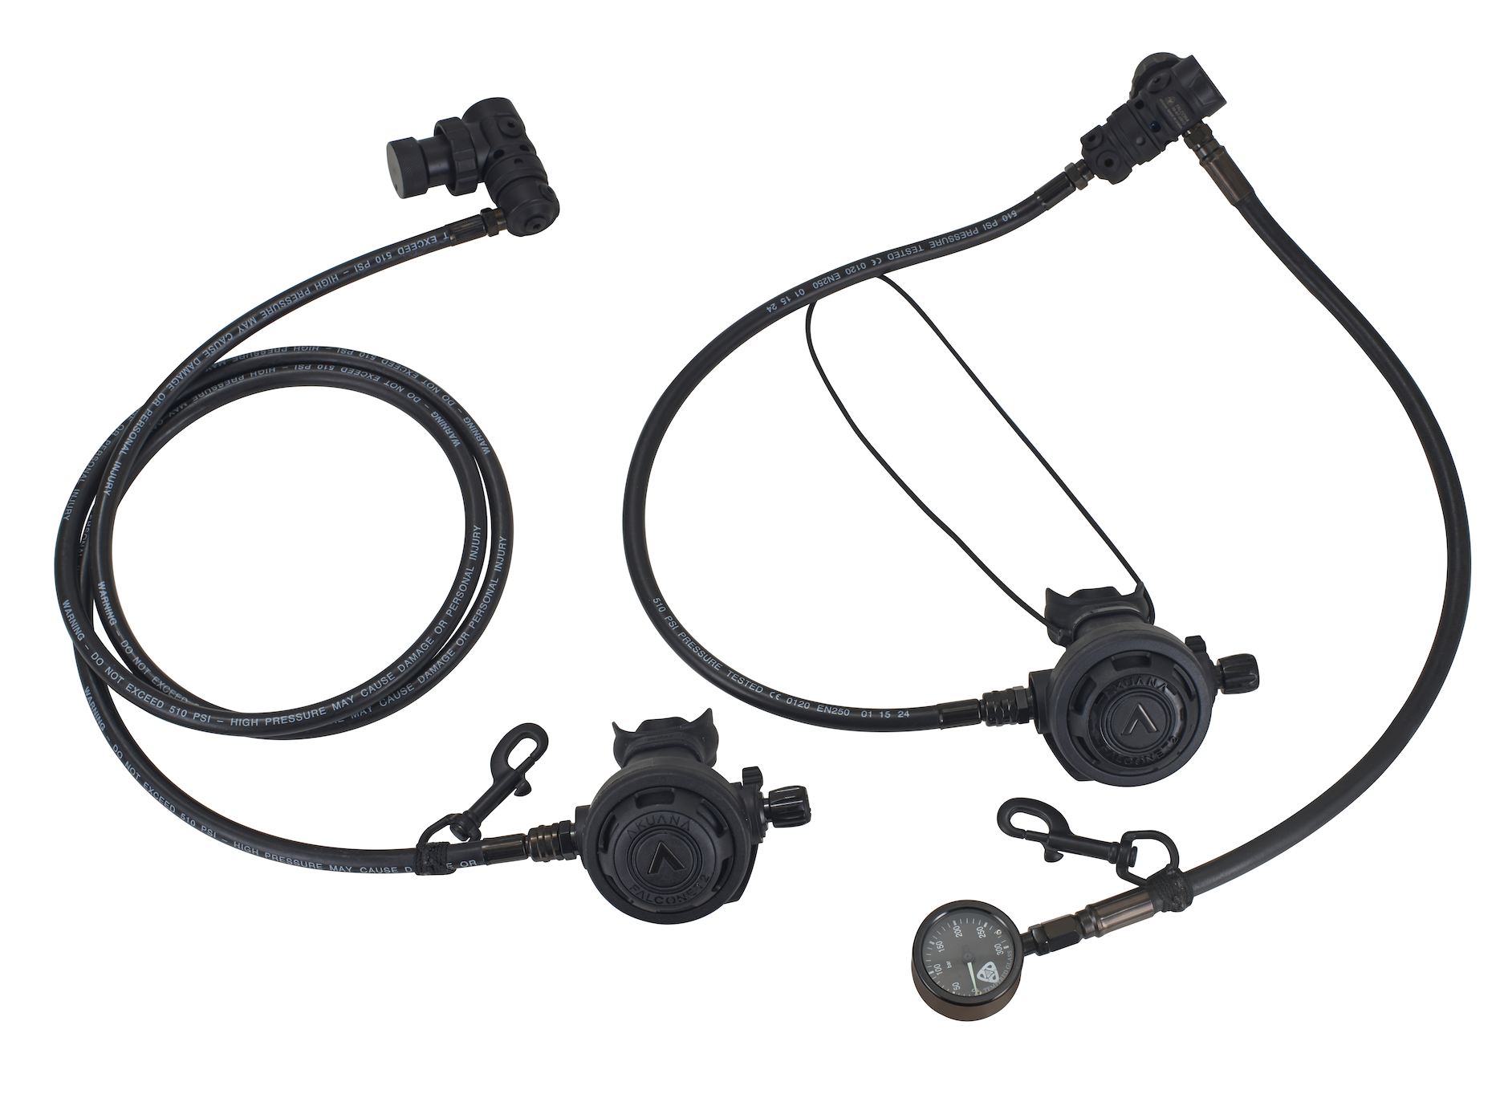

D. Sidemount package Number____

1) F3/FN2 2) F4/FN2
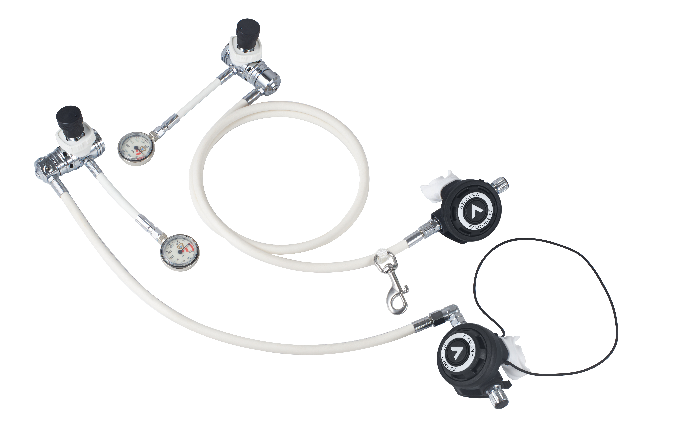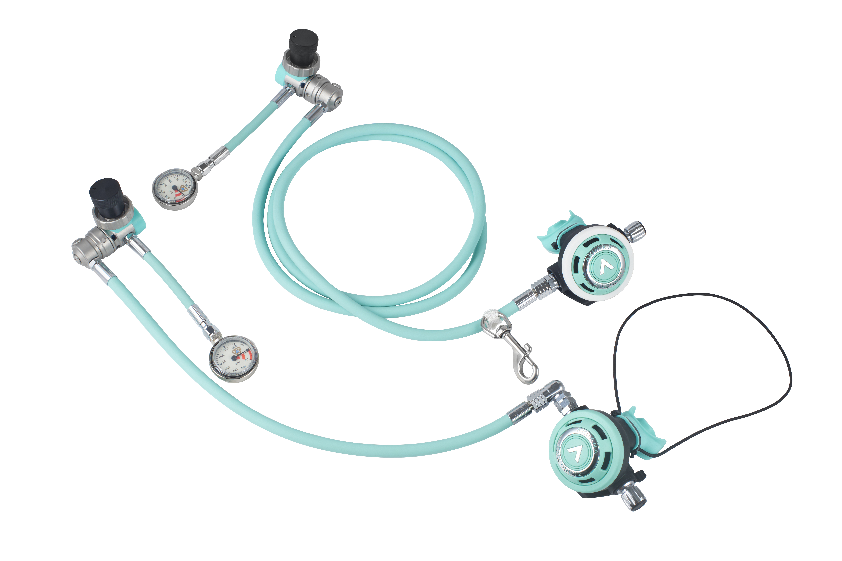
3) F3/FN2 Gunmetal package（gunmetal hoses） 4) F4/FN2 Gunmetal package（gunmetal hoses）

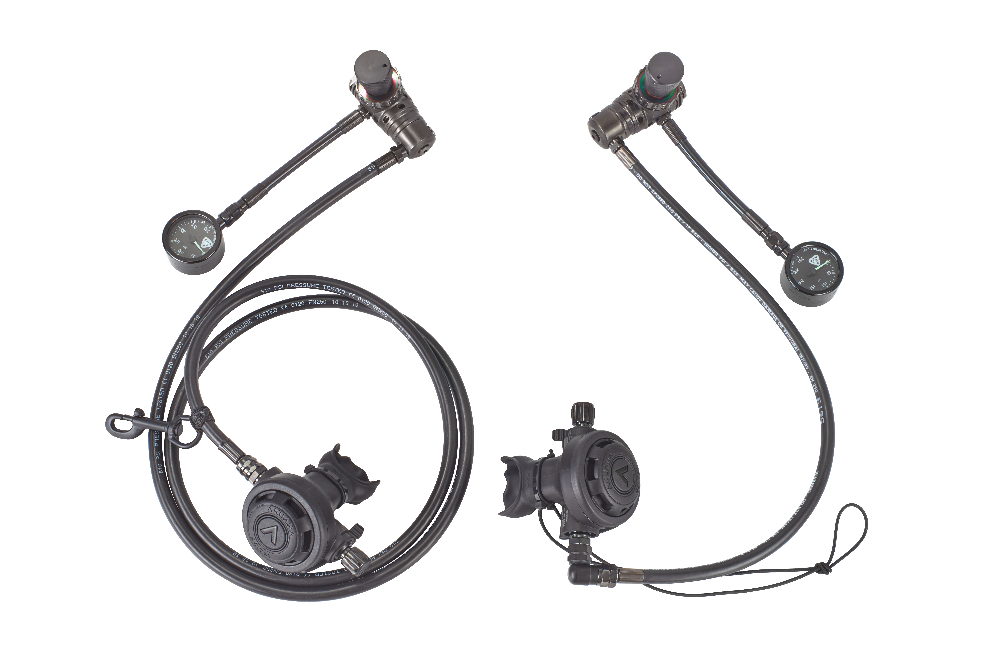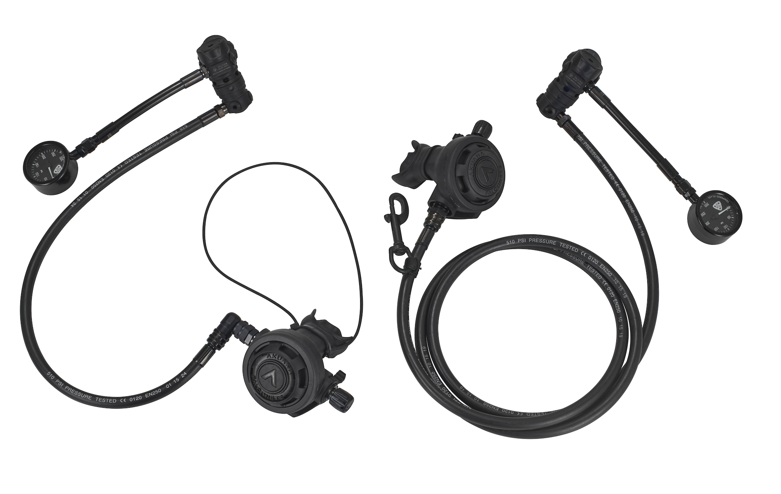
5) F4/FN3 package (Gunmetal hoses)
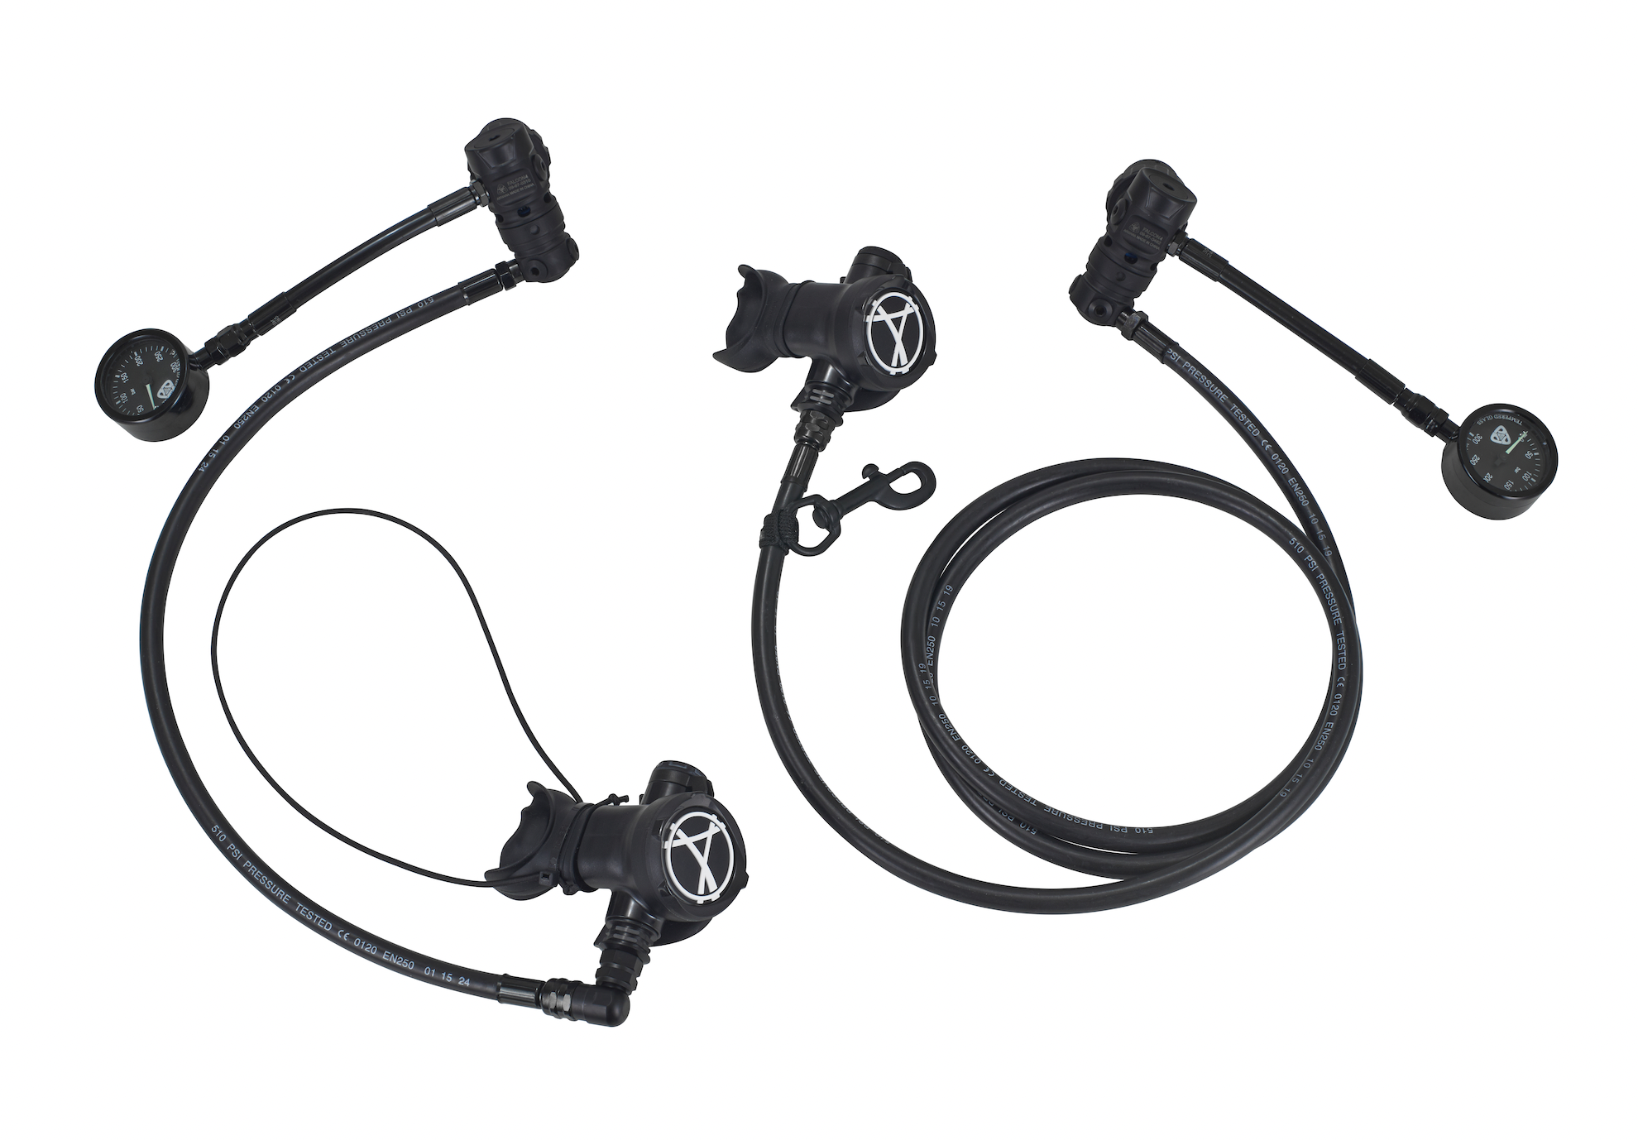

E. Deco tank package
1) F3 一级头+FN2 二级头

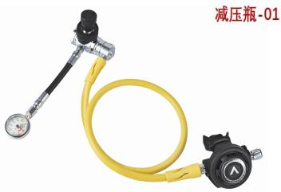
Step 2: Choose the second stage (Gunmetal versions will come with the package)

- Falconet2 Color series

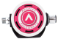Pink Blue 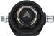BlackYellow
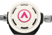White 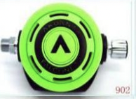Green

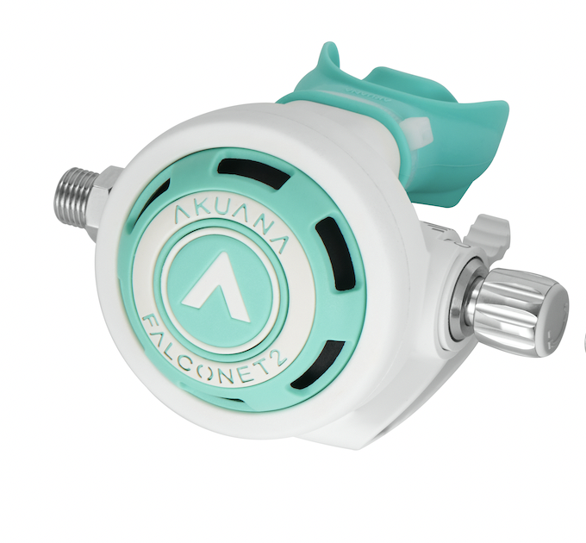Lake blue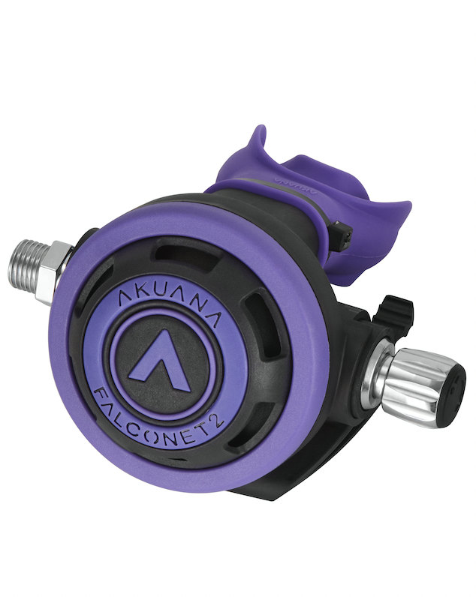 Purple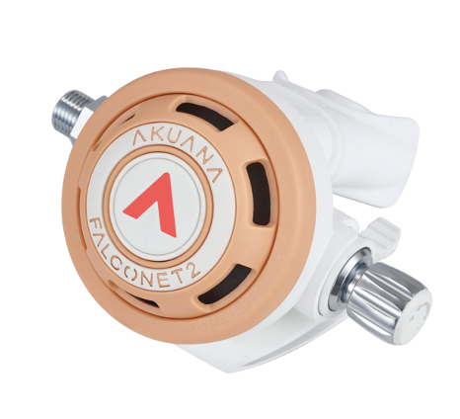 Peach fuzz 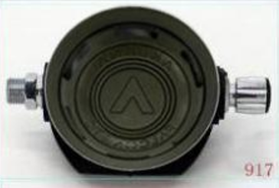Oliver

Falconet2 cover choice

Primary FN2 Number____

Backup FN2 Number____

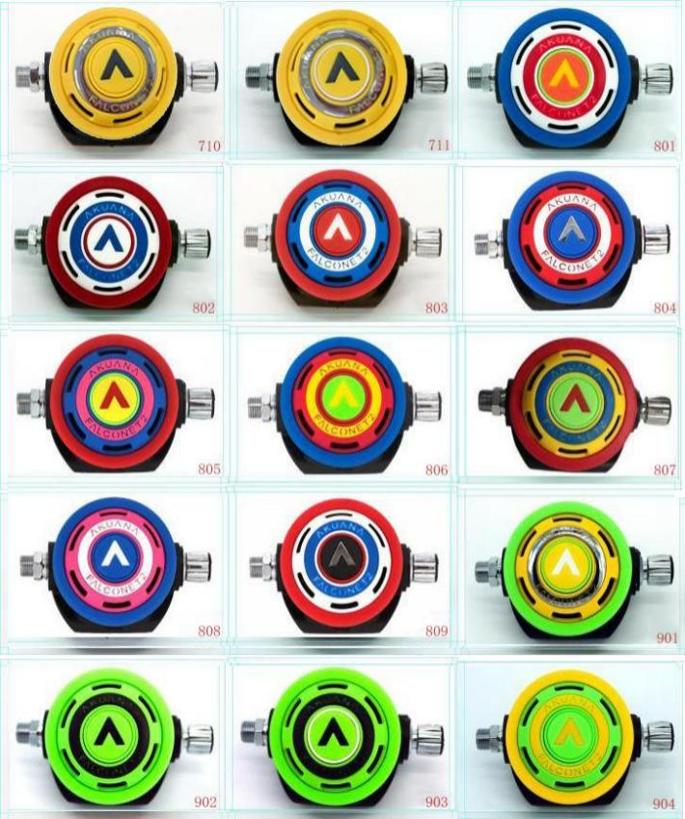
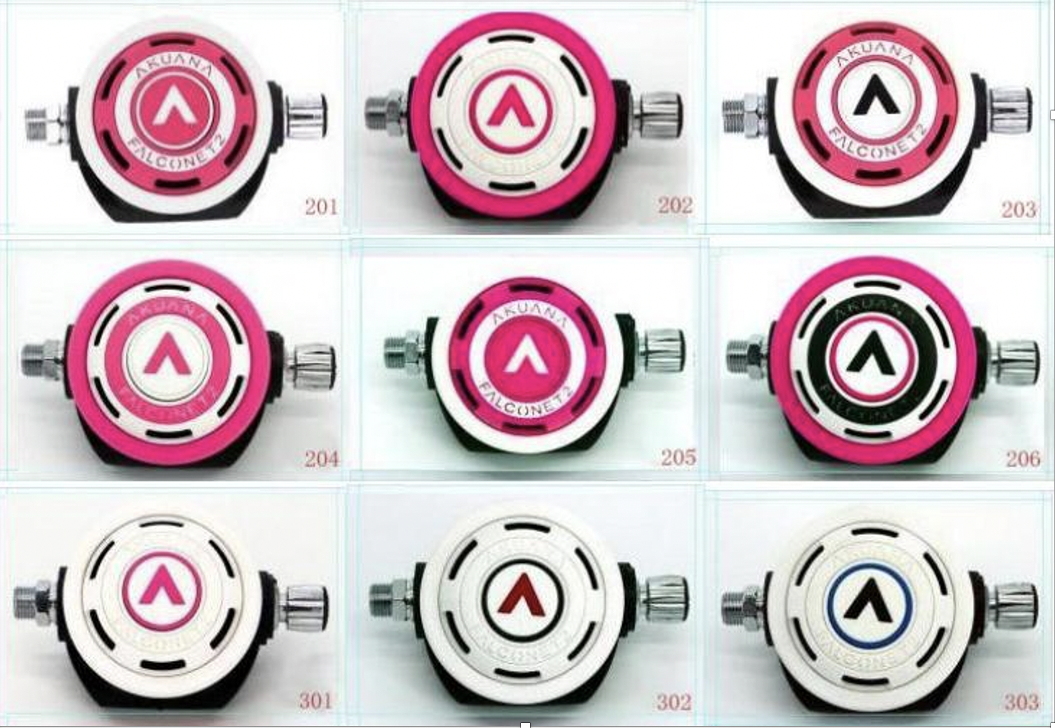

- Falconet 3 color choice

Primary FN2 Number____

Backup FN2 Number____

- Lake blue 2. Purple 3. White 4. Pink 5. Peach fuzz

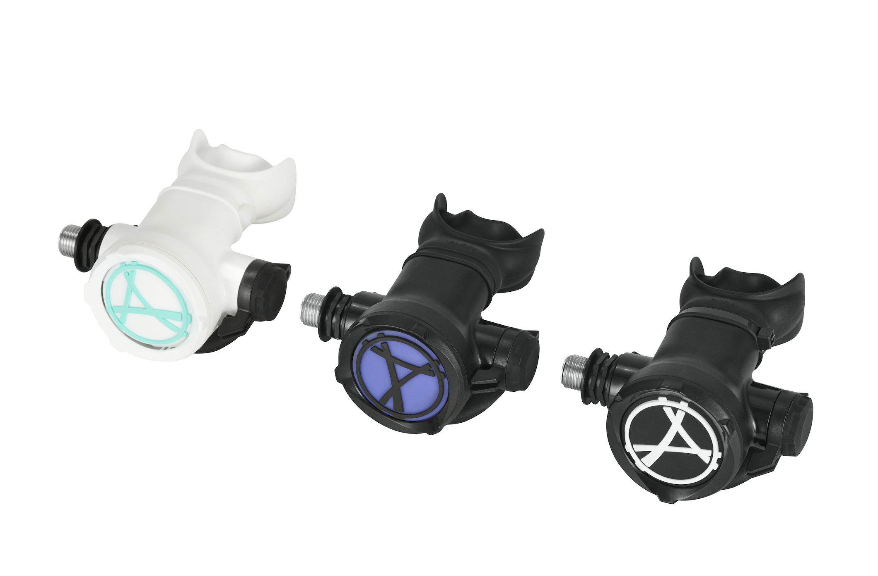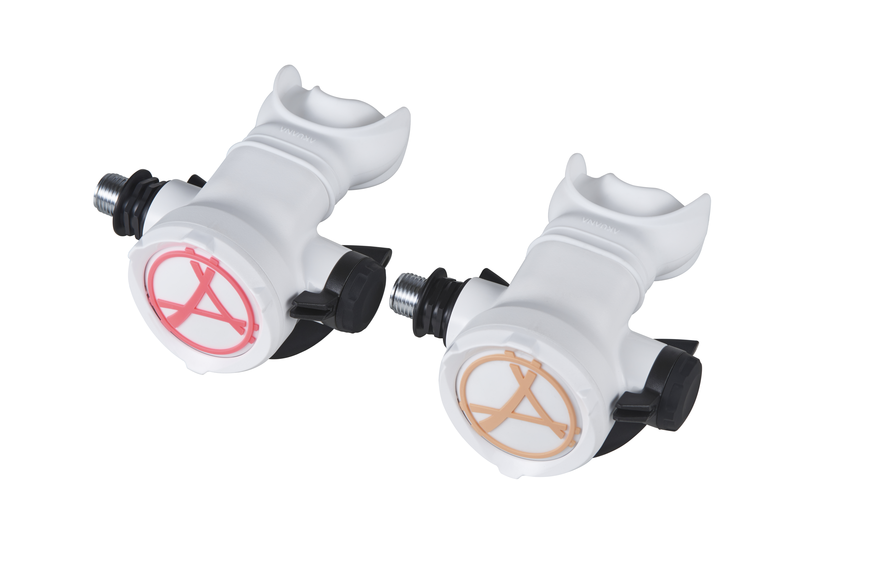

Step 3: Choose the first stage (plastic part)
NO.1 First stage Number____
No.2 First stage Number____ (for double tank and sidemount)
- Falcon 3
1.Pink 2.Blue 3.Black 4.White 5.Lake blue 6.Purple 7.Peach fuzz 8.Oliver

- Falcon 4
1.Pink 2.Blue 3.Black 4.White 5.Lake blue 6.Purple 7.Peach fuzz 8.Oliver

- Falcon 5
1.Black

Step 4: Choose the hose color (Gunmetal versions come with black hoses)
- OW package
Primary second stage hose （76cm） Number____
1. Black 2. Lake blue 3. White 4. Pink 5. Blue

Backup second stage hose (104cm) Number____
1. Black 2. Lake blue 3. White 4.Pink 5. Blue
6 Yellow

HP hose （61cm）Number____
1. Black 2. Lake blue 3.White 4. Pink 5. Blue

- Hogar package

Primary second stage hose （200cm） Number____
1. Black 2. Lake blue 3. White 4. Blue

Backup second stage hose (56cm) Number____
1. Black 2. Lake blue 3. White 4. Blue

HP hose （61cm）Number____
1. Black 2. Lake blue 3.White 4. Pink 5. Blue

- Double tank
Primary second stage hose （200cm） Number____
1. Black 2. Lake blue 3. White 4. Blue

Backup second stage hose (56cm) Number____

1. Black 2. Lake blue 3. White 4. Blue

HP hose （61cm）Number____
□ Black □ Lake blue □ White □ Pink □ Blue

- Sidemount package
Primary second stage hose （200cm） Number____
1. Black 2. Lake blue 3. White 4. Blue
Backup second stage hose (61cm) Number____
1. Black 2. Lake blue 3. White
HP hose （15cm）
Black

- Deco tank package
Regulator hose (104cm) Number____

1. Black 2. Lake blue 3. White 4.Pink 5. Blue
6 Yellow
HP hose （15cm）
Black

